Know Your Rights,

Liberty Union High School District!

**Did you know you have the right to receive various**

**CONFIDENTIAL & PRIVATE health services?**

Students have a right to receive various confidential health services without consent from your parents! These include medical services such as HIV/STD testing and treatment, pregnancy testing, abortion, and contraceptives; mental health services if you are suffering from a disorder such as anxiety or depression; drug and alcohol treatment; and sexual assault services. Let us show you how to get them!

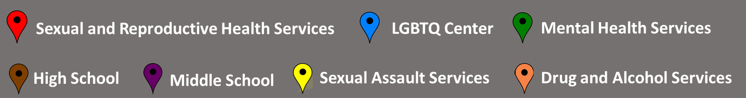

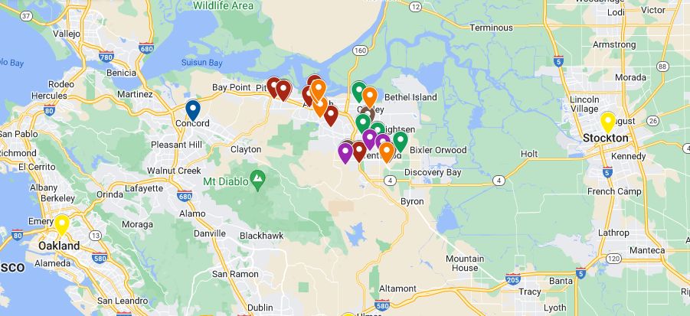

**Click this link to view the map:** [**https://www.google.com/maps/d/u/0/edit?mid=1Q1-stxLR64yFKBhImG5hah8YWw0Ehx0&usp=sharing**](https://www.google.com/maps/d/u/0/edit?mid=1Q1-stxLR64yFKBhImG5hah8YWw0Ehx0&usp=sharing)

|  |  |  |  |  |
| --- | --- | --- | --- | --- |
| **Name** | **Address** | **City** | **Phone Number** | **Services Offered** |
| La Clínica Oakley | 2021 Main Street | Oakley | 925-363-2000 | * Immunizations * Physical Exams * Lab Tests * Services for Chronic Illnesses * Pregnancy Testing * HIV & STD testing |
| La Clinica Pittsburg | 2240 Gladstone Drive | Pittsburg | 925-431-2100 | * Immunizations * Physical Exams * Lab Tests * Services for Chronic Illnesses * Pregnancy Testing * HIV & STD testing |
| Brentwood Care Center | 350 John Muir Parkway | Brentwood | 925-513-2483 | * Pregnancy and Childbirth Services * Gynecology and Women's Health * HIV & STD testing |
| Contra Costa Health - Antioch Health Center | 2335 Country Hills Drive | Antioch | 925-608-8500 | * Family Medicine * Prenatal Care * HIV & STD testing |
| Pittsburg Health Center | 2311 Loveridge Road, East Clinic | Pittsburg | 800-495-8885 |  |
| Brighter Beginnings Family Health Clinic | 3505 Lone Tree Way #1 | Antioch | 925-303-4780 | * Family support program and health clinic * Teen parenting support * Pregnancy and women’s health services * HIV & STD testing |
| Brighter Beginnings Health Clinic/La Clinica de Salud | 512 West 5th Street | Antioch | 877-427-7134 | * Family support program and health clinic * Teen parenting support * Pregnancy and women’s health services   HIV & STD testing |
| Planned Parenthood | 1104 Buchanan Rd STE C10 | Antioch | 925-754-4550 | * Abortion * Birth Control * Emergency Contraception (Morning-After Pill) * Gender-Affirming Care * HIV Services * Pregnancy Testing and Planning * STD Testing and Treatment * Sexual and Reproductive Concerns * Vaccines * Wellness and Preventive Care |
| La Clinica de La Raza | 337 East Leland Road | Pittsburg | 925-431-1250 | * Family Planning Services * Birth control and safe sex education * Diagnosis and treatment of sexually-transmitted and other infections |
| Contra Costa County Health - Pittsburg Health Center | 2311 Loveridge Road | Pittsburg | 800-495-8885 | * HIV Specialty Services * Family services * Immunizations * Sexual Health Clinics * Women’s health * HIV & STD testing |
| Birthright of Brentwood | 857 2nd Street, Suite D | Brentwood | 925-634-1275 | * Pregnancy testing and counseling * Crisis pregnancy center |
| La Clínica Oakley Behavioral Health – Casa de Luz | 2005 Main Street, Suite #C | Oakley | 925-776-8223 | * Mental health services |
| Healthy Minds Counseling Center | 191 Sand Creek Road, Suite 231 | Brentwood | 925-663-8158 | * Mental health treatment * Treatment for co-occurring substance use plus serious mental health illness/emotional disturbance |
| Discovery Mood & Anxiety Program - Brentwood | 795 Eden Plains Road | Brentwood | 855-419-0579 | * Substance use treatment * Mental health treatment * Treatment for co-occurring substance use plus serious mental health illness/emotional disturbance |
| Discovery Mood & Anxiety Program - Brentwood | 2324 Windy Springs Lane | Brentwood | 925-961-3489 | * Substance use treatment * Mental health treatment * Treatment for co-occurring substance use plus serious mental health illness/emotional disturbance |
| Rainbow Community Center of Contra Costa County | 2380 Salvio Street, Suite 301 | Concord | 925-692-0090 | * Suicide Prevention * STD/HIV Counseling, Education, Prevention, and Testing * Mental Health Support * Addiction/ Recovery Counseling * Health & Wellness |
| Tri-Valley Haven | 3663 Pacific Avenue | Livermore | 800-884-8119 | * Domestic Violence Services * Sexual assault services * Family support services |
| Bay Area Women Against Rape | 470 27th Street | Oakland | 510-800-4247 | * Sexual assault services * Confidential hotline * Crisis and immediate response * Restorative coaching * Emergency accompaniments |
| PREVAIL | 729 N California Street | Stockton | 209-941-2611 | * Case management * 24-hour hotline * Counseling * Legal/Criminal Justice Systems Advocacy * Crime Victim Assistance Advocacy * Emergency Shelter * Hospital Accompaniment |
| Addiction Research and Treatment Inc (ART)/Bay Area | 3707 Sunset Lane | Antioch | 925-522-0124 | * Substance use treatment |
| J Cole Recovery Homes Inc Cole House | 1408 A Street | Antioch | 925-978-2873 | * Substance use treatment |
| REACH Project REACH Brentwood | 9100 Brentwood Blvd | Brentwood | 925-666-8460 | * Substance use treatment * Relapse prevention * Substance use disorder counseling * Trauma-related counseling |
| REACH Project REACH Oakley | 3385 Main Street, Suite B | Oakley | 925-679-2504 | * Substance use treatment * Relapse prevention * Substance use disorder counseling * Trauma-related counseling |
| REACH Project REACH Central | 1915 D Street | Antioch | 925-754-3673 | * Substance use treatment * Relapse prevention * Substance use disorder counseling * Trauma-related counseling |

# What Can I Consent To?

Teen Health Rights

* As a minor, you have the right to: consent to medical care related to the prevention or treatment of pregnancy; receive birth control; access abortion care; access care if you have been raped or sexually assaulted including diagnosis, treatment, and collection medical evidence; access mental health treatment or counseling on an outpatient basis, or to residential shelter services; access services to diagnose and/or treat infectious, contagious communicable diseases, and sexually transmitted diseases including HIV/AIDS; and access medical care and counseling related to the diagnosis and treatment of a drug or alcohol related problem.

# What Does Confidentiality Mean?

* Confidentiality means privacy. It means that you, as a minor, can talk to your health care provider about ANYTHING and they will not tell your parents or guardians what you talk about unless YOU give them YOUR permission. However, some things cannot remain confidential. Your health care provider will need to contact someone else to help if you are being abused either physically and/or sexually and/or if you are going to hurt yourself or someone else.

# For more information on your rights as a minor, please visit [teenhealthrights.org](http://www.teenhealthrights.org/).

Resources

**Medical Resources**

* [PlannedParenthood.org](https://www.plannedparenthood.org/) – Provides information and resources for teens, parents, and educators.
* [TeensHealth.org](https://teenshealth.org/en/teens/) – Provides general health information, including information about diseases and infections, sexual health, the consequences of drug and alcohol use, and mental health.
* [TeenSource.org](https://www.teensource.org/) – Provides California teens sexual health information and includes a clinic f inder to help teens locate clinics in their area within California.
* [Bedsider.org](https://www.bedsider.org/) – Provides an online birth control support network.
* [FamilyPact.org](http://familypact.org/) – Family PACT (Planning, Access, Care, & Treatment) is a California state program that provides free family planning services to low income residents.

# Crisis Support Resources

* [ChildHelp.org](https://www.childhelp.org/) – This national organization is dedicated to supporting victims of child abuse and neglect. They also run a 24/7 hotline.
* [Rainn.org](http://rainn.org/) – RAINN is the largest anti-sexual assault organization in the nation and runs the 24/7 National Sexual Assault Hotline.
* [LoveIsRespect.org](https://www.loveisrespect.org/) – Provides anonymous and confidential communication and resources about dating violence.

# LGBT Resources

* [ItGetsBetter.org](https://itgetsbetter.org/) - The It Gets Better Project’s mission is to uplift, empower, and connect lesbian,

gay, bisexual, transgender, and queer (LGBTQ+) youth around the globe.

* [Eqca.org](https://www.eqca.org/) – Equality California is the nation’s largest statewide lesbian, gay, bisexual, and

transgender civil rights organization dedicated to creating a fair and just society.

* [Glsen.org](https://www.glsen.org/) – The Gay, Lesbian, and Straight Education Network works to make K-12 school communities safe and accepting of all members.

# 24/7 Emergency Hotlines

* California Youth Crisis Hotline – 1-800-843-5200
* Childhelp National Child Abuse Hotline – 1-800-422-4453
* Kristin Brooks Hopeline Suicide Hotline – 1-800-784-2433
* The Trevor Project Suicide Hotline for LGBT Youth – 866-488-7386
* Trans Lifeline – 877-565-8860
* National Domestic Violence Hotline – 1-800-799-7233
* National Sexual Assault Hotline – 1-800-656-4673
* National Dating Abuse Hotline – 1-866-331-9474
* Rape Counseling Service Hotline – 559-222-7273
* National Smoking Quitline – 1-800-784-8669
* National Drug and Alcohol Treatment Referral Routing Service – 1-800-662-4357